**FINGER VEIN DETECTION USING DEEP LEARNING**

# A PROJECT REPORT

***Submitted by***

**ANBARASU.J**

**KABISH M.E**

**MITHRAN.J**

**MOHAMMED ARSHATH.S**

***in partial fulfillment for the award of the degree of***

**BACHELOR OF ENGINEERING**

**IN**

# ELECTRONICS AND COMMUNICATION ENGINEERING

**SARANATHAN COLLEGE OF ENGINEERING, TIRUCHIRAPPALLI**



**ANNA UNIVERSITY: CHENNAI 600 025**

# MAY-2024

**ANNA UNIVERSITY: CHENNAI 600 025**

**BONAFIDE CERTIFICATE**

Certified that this project report **“FINGER VEIN DETECTION USING DEEP LEARNING”** is the bonafide work of “**ANBARASU.J, KABISH.M.E, MITHRAN.J, MOHAMMED ARSHATH.S”** who carried out

the project work under my supervision.

**SIGNATURE SIGNATURE**

Dr. M.SANTHI M.E., Ph.D., Dr. P.SHANMUGAPRIYA

**HEAD OF THE DEPARTMENT SUPERVISOR**

Professor Professor

Electronics and Communication Electronics and Communication

Engineering, Engineering,

Saranathan College of Engineering, Saranathan College of Engineering,

Panjappur, Panjappur,

Trichy-620012 Trichy-620012

**CERTIFICATE OF EVALUATION**

**College Code :** 8138

**College Name :** Saranathan College of Engineering

**Branch :** Electronics and Communication Engineering

**Semester** VIII

**Subject :** EC8811 - Project Work

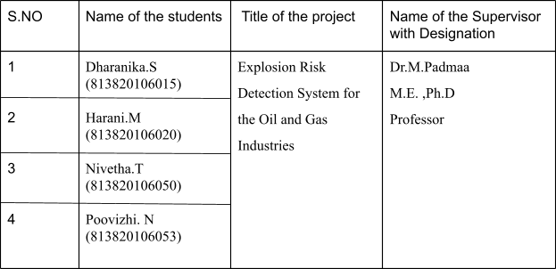

The report of the project work submitted by the above students in partial fulfillment for the award of Degree of Bachelor of Engineering in Electronics and Communication Engineering of Anna University: Chennai was confirmed to be the work done by the above students and evaluated on

**INTERNAL EXAMINER EXTERNAL EXAMINER**

# ACKNOWLEDGEMENT

We extend our sincere gratitude to **Shri. S. RAVINDRAN**, our Secretary at Saranathan College of Engineering, for his unwavering dedication to our education within our esteemed institution.

Our heartfelt thanks go to **Dr. D. VALAVAN**, the Principal of Saranathan College of Engineering, for allowing us to pursue this project.

We sincerely thank **Dr. Y. VENKATARAMANI**, the Dean (R&D) at Saranathan College of Engineering.

We are profoundly grateful to **Dr. M. SANTHI**, Head of the Department of Electronics and Communication Engineering, for her steadfast support, inspiration, and constant encouragement throughout the project.

Our gratefulness extends to our esteemed Project Coordinator, **Dr. C.VENNILA, Ph.D., Professor**, for effectively coordinating the project activities. We also extend special thanks to our esteemed panel members, **Dr. S. RAJESWARI, M.Tech., Ph.D., Associate Professor**, and **Dr. M. BARITHA BEGUM, M.E., Ph.D., Associate Professor**, for their invaluable suggestions and keen interest at every stage of the project.

We are immensely pleased to acknowledge our supervisor, **Dr.P.SHANMUGAPRIYA, M.E ,Ph.D., Professor**, for graciously accepting us as project students. The entire duration of our project has been an excellent learning curve due to her wisdom, advice, motivation, and valuable suggestions.

**TABLE OF CONTENTS**

**ACKNOWLEDGEMENT ABSTRACT**

|  |  |  |
| --- | --- | --- |
| **CHAPTER NO.** | **TITLE** | **PAGE NO.** |
| **1.** | **INTRODUCTION** |  |
| 1.1 | IMAGE PROCESSING |  |
| 1.2  1.3  1.4 | DEEP LEARNING  OVERVIEW OF PROJECT  OBJECTIVE OF PROJECT |  |
| **2.** | **LITERATURE SURVEY** |  |
| **3.** | **SYSTEM ANALYSIS** |  |
| 3.1  3.2  3.3 | PROBLEM DESCRIPTION  EXISTING SYSTEM  PROPOSED SYSTEM |  |
| **4.** | **SYSTEM SPECIFICATION** |  |
| **5.** | **SYSTEM IMPLEMENTATION** |  |
| 5.1 | MODULES |  |
| 5.1.1 | MODULE DESCRIPTION |  |
| **6.** | **RESULT AND DISCUSSION** |  |
| **7.**  **8.** | **CONCLUSION AND FUTURE ENANCEMENT**  **REFERENCE** |  |
|  |  |  |
|  |  |  |